TECHNICAL MANUAL:
Calibration Procedures and Parts List

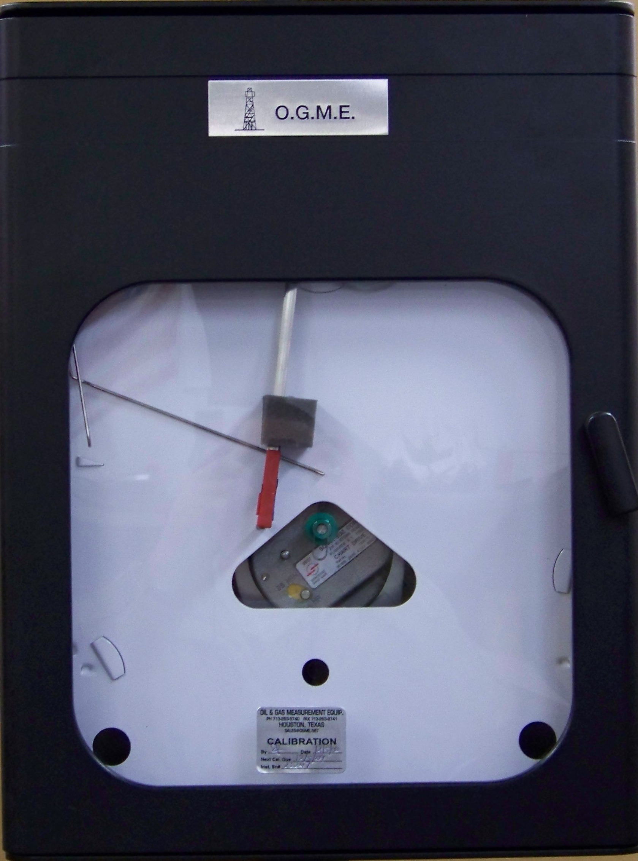

Oil and Gas Measurement
5227 Dow Road
Houston, TX 77040
PH: 713-263-9740
FAX: 713-263-9741

Oil & Gas Measurement Equipment, Inc.

5227 Dow Road – 77055
P.O. Box 55641 ∗ Houston ∗ TX ∗ 77255
Ph: 713-263-9740 ∗ 713-686-3444
Fx: 713-263-9741
Email: sales@ogme.net
OGME, Inc.

WARRANTY

O.G.M.E. (Seller), warrants new products actually manufactured by it and against defective workmanship and material when under normal and proper use in service for 12 months from the date of delivery of goods to purchaser, provided Purchaser subjects the equipment only to the operating conditions specified by the Purchaser when the order is placed and in accordance with the Seller’s written operating instructions, if any. Component manufacturers’ guarantees shall be passed to Purchaser; Seller does not warrant components.

Should Seller’s product be defective in either materials or workmanship, Seller shall repair the defective part or furnish a replacement part f.o.b. Seller’s fabrication plant, at Seller’s election: No warranty shall apply to parts repaired or altered by Purchaser without Seller’s prior written consent.

Seller makes no warranty with respect to workover or service work to parts requiring replacement due to wear and tear or to used equipment and or to painting/coating/lining. EXCEPT FOR THE WARRANTY EXPRESSLY STATED ABOVE, THERE ARE NO OTHER WARRANTIES AND NONE SHALL BE IMPLIED BY LAW, INCLUDING THOSE OF MERCHANTABILITY AND FITNESS FOR A PARTICULAR PURPOSE.

INDEX

SPECIFICATIONS 4
WARNINGS 5

SECTIONS I - THEORY OF OPERATIONS 6
COMPONENT FUNCTIONS 6

SECTION II - INSTALLATION 7
INSPECTION 7
MOUNTING 7
PROCESS CONNECTIONS 8
PRELIM. LEAK CHECK, STATIC 9
PRELIM. LEAK CHECK D/PU 9
PRELIM. ZERO CHECK, D/PU 9

SECTION III - STARTUP CHECKPOINTS 10
PEN DRAG 10
PEN SKIPPING 10
PEN/TIME LINE 10
IMPROPER RANGE SPRING SETTING 11
PEN SPEED ADJUSTMENT 11

SECTION IV – CALIBRATION 12
STATIC PRESSURE 12
THERMAL SYSTEM 13
DIFFERENTIAL PRESSURE 13
TORQUE TUBE ADJUSTMENT FIG 3.4 15
RECORDER PARTS LIST 17
RECORDER DIMENSIONS 20

SPECIFICATIONS

Housing
Case……………………………………………………………. Die Cast Aluminum
Paint……………………………………………………………. Electromagnetic Powder Coat, Black
Hinge…………………………………………………………… 304 Stainless
Gasket……………………………………………………..……Closed Cell Neoprene
Window………………………………………………………… Plexiglass
Pens & Linkages………………………………………………Stainless
Pen Bracket……………………………….……………………Cast Aluminum

Static Elements
Material………………………………………………………... 316 Stainless Steel
Pressure Ratings……………………………………………... 50 – 30,000 PSI
Accuracy…………………………………… …………………..± 1% 0.5% Full Scale (URV)

Thermal Elements
Material……………………………………………...................316 Stainless Steel
System Type……………………………………………………S.A.M.A. CLASS 5-B
………………………………………...................................... Mercury Filled, Case Compensated
Capillary………………………………………………………...Armored, 10’ Standard
Ranges…………………………………….……………………-20ºF to 300ºF
Accuracy………………………………………………………..± 0.5% Full Scale (URV)
DP Ranges……………………………………………………. 0- 20” WC to 0- 400” WC

Differential Pressure Unit
Material
DP HOUSING……………………..………………… AISI-1040 Forged Steel Zinc Plated
Bellows……………………………..…………………316 L Stainless
Range Springs……………………..……………….. Inconel 600
“O” Rings…………………………...…………………90d Viton
Safe Working Pressure………………………………………. 2500 PSI up to 5000 PSI
Temperature Limits……………………….. …………………. -20ºF to 180ºF
Fill Liquid…………………………………… …………………. “M” Fill
Accuracy………………………………………………………. ± -.50% Full Scale (URV)
DP Ranges……………………………………………………. 0- 20” WC to 0- 400” WC

WARNINGS

The warranty will be voided if the following precautions are ignored:

SHOCK: Recorder linkages and D/P units are delicate. Do not subject the instrument to shock loads. Handle and transport the unit with care. In liquid service prevent hydraulic shock or “water hammer” from reaching the instrument by installing pulsation dampeners, snubbers or seal pots.

VIBRATION: Continuous mechanical vibration will cause excessive wear of bearings, linkage connections and non-lubricated journals. It can also accelerate metal fatigue in highly stressed pressure containing parts. The results of vibration will be loss of instrument accuracy, hysteresis of pen movements or fluid loss from the sealed bellows unit.

PRESSURE: Do not subject any part of the instrument to pressures exceeding those stamped on the pressure containing parts.

TEMPERATURE: Ambient temperature limits are -60º to +180ºF. If the recorder is equipped with a thermal element, the process temperature limits will be stamped on the element tag.

CORROSION: Pressure containing parts exposed to process fluids are constructed of materials in accordance with the recommendations of the NACE MR-01-75 to resist hydrogen sulfide stress cracking. This does not automatically prevent corrosion. If the process media or atmosphere is corrosive, precautionary measures must be taken to protect the instrument.

SEALED COMPONENTS: The center plate and bellows assembly of the D/P unit have been factory filled and sealed as a unit.
……………………..……………….………………… DO NOT remove the top fill plug on the center plate.
……………………..……………….………………… DO NOT remove the dampener adjusting screw.
……………………..……………….………………… DO NOT loosen the torque tube gland nut.
……………………..………………..…………………DO NOT remove the low pressure bellows seal plug. (under the range spring adjusting post)
……………………..………………..…………………DO NOT unscrew either bellows from the centerplate.

ANY OF THE ABOVE WILL CAUSE A LOSS OF FILL FLUID AND WILL RENDER THE D/P UNIT INOPERABLE.

SECTION I
THEORY OF OPERATION
(See Fig. 1.1)

- GENERAL. This manual is provided to give basic installation, operation and maintenance instructions for all OGME recorders including pressure, temperature, and differential pressure. The 3 pen recorder contains all three recording systems, and therefore certain portions may not be applicable to all instruments.

- THEORY OF OPERATION. Changes in the parameters to be measured (P, T, & D/P) cause physical movements of their sensing elements in the case. These small movements which are amplified and transferred by linkages to a pen which transcribes its movement to a rotating circular chart, leaving a permanent record of process conditions.

- COMPONENT FUNCIONS.

  - STATIC PRESSURE ELEMENT. It is sometimes called the static ‘spring’ and is a helically wound hollow tube with a post fixed to its free end and positioned in the center of the helix. Increasing pressure causes the tube to attempt to straighten out which rotates the center post. This rotating movement is transferred to the static pressure pen through a linkage system. Maximum operating pressure is stamped on the mounting plate.

  - THERMAL ELEMENT. This element is similar to the static element except it is wound in a spiral. The fixed end of the tube is connected to a flexible capillary with a hollow bulb on the end. The entire system is filled under vacuum with a fluid that expands relative to its temperature. The fluid expansion causes the spiral tube to attempt to straighten, thus imparting a rotary motion to its center post. This rotary motion is amplified and transferred to the temperature pen by a linkage mechanism.

The process temperature range of the system is stamped on the element in degrees Fahrenheit.

The mass of the thermally sensitive fluid in the bulb is far greater than the mass of the fluid in the capillary and spiral tube making the system much more sensitive to process temperature than it is to ambient temperature.

A bi-metallic strip on the element drive arm compensates for the ambient temperatures, thus the recorded temperature is the actual process temperature.

  - DIFFERENTIAL PRESSURE ELEMENT. Two flexible metal bellows are attached to a center plate. The bellows and center plate cavity are liquid filled under a vacuum (shaded area). A center shaft connects the two bellows and they move together. Movement to the right is opposed by tension range springs in the low pressure (L) cavity.

When the pressure in the high pressure (H) cavity exceeds the pressure in the (L) cavity, the (A) bellows contracts forcing fill fluid into the (B) bellows which expands. This fluid exchange causes the center shaft to move to the right imparting a counterclockwise movement to the D/P unit output shaft (C). If the pressure in the (H) & (L) equalized the range spring returns the center shaft to its starting position and the output shaft cam follows since the friction free torque tube seal is itself a spring load in a clockwise direction.

Fluid flow between chambers (A) and (B) is restricted by a piston ring type seal on the center shaft and fluid must flow past a dampener valve (D). This allows flow line pulsations to be dampened.

This valve is set at the factory and the fill fluid is a fluid that has a uniform viscosity/temperature curve and the valve normally need not be field adjusted.

SECTION II
INSTALLATION
(See FIG. 2. 1)

- INSPECTION.

Carefully examine the recorder for damage that may have occurred during shipment.

All element and pen movements have been factory calibrated. Do not change any linkage
adjustments during this inspection procedure.

If the recorder is equipped with a Differential Pressure Unit (D/PU) a chart record of the final factory calibration will be on the chart plate.

- MOUNTING.

It is important that the instrument be firmly mounted and that the chart plate is in a true vertical position. A tilted instrument will result in uneven pen drag on the chart paper, creating measurement errors. Avoid mounting in walls or to pipes that vibrate or in locations where corrosive gasses are vented.

The case is weatherproof and rain tight, but sun and rain will eventually degrade the elastomer seals. It is advisable to protect the recorder with a light gauge rain/sun shield or meter house.

- PANEL/WALL MOUNTING

If the instrument has been ordered for panel or wall mounting, it will have 3 brackets attached per
Figure 2.1.

Panel mounting cutout dimensions are shown in Figure 2.1
If panel is very thin, it may be necessary to install a nut and bolt extension to the bracket leg or
re-drill the bolt holes in the case.

- PIPE MOUNTING.

The D/P Unit has a 2" pipe size female adaptor to slip over plain ended 2 3/8" O.D. pipe. Three set
screws will secure the recorder to the pipe. Again, be sure the recorder is vertical to insure proper pen movement.

- PROCESS CONNECTIONS.

  - TEMPERATURE.
Install the thermowell sot he the thermal bulb will be located at a point where the temperature will be representative of the actual process. In a flowing stream, this is as near the center of the pipe as possible. Avoid locating the bulb near pipe walls or cooling/heating coil.

Avoid sharp bends with a radius less than 3' in the capillary line.

For faster recorder response fill the thermowell with a heat conducting medium such as “COPPERCOAT” before installing the thermal bulb.

  - STATIC PRESSURE ELEMENT.
Install a valve next to the process where the static pressure element is to be connected.

If the pressure recorder is equipped with a D/P Unit and intended to record gas flow, the static pressure should be taken from the downstream orifice tap. If a 5 valve preformed manifold is supplied, this connection has been pre-tubed into the manifold.

If the process fluid is gas, the lines should slope downward from the recorder toward the process to drain condensation.

If the process fluid is liquid, it is generally recommended the line slope downward from the process toward the recorder.

If the process fluid is corrosive or hazardous, a seal pot should be installed in the line to protect the instrument and the service personnel.

If the line pressure pulsates a pulsation dampener should be installed in the line.

  - DIFFERENTIAL PRESSURE UNIT.
The letters H and L (for high and low pressures) have been stamped on the center plate of the D/P Unit on each side of the unit serial number indicating which side of the unit connects to high and low pressures of the differential to be measured.

If gas flow is being measured, it is recommended the D/P Unit be installed above the flow line, (Fig. 2.2 A) The lower ¼” NPT end cap connections should be used and the tubing sloped toward the orifice taps to drain condensate away from the D/PU. If it is necessary to install the D/PU below the flow line, the drip pots should be installed per Fig. 2.2 B.

If hydrates or heavy solids will be present, drip pots must be installed and special equalizer tubing used per Fig. 2.2 C.

If liquid flow or liquid head is being measured, the D/PU should be mounted lower than the process connections, the tubing sloped to vent vapor from the D/PU through the ½" connections in the end caps. Fig 2.2 D.

For steam measurement the D/PU should be mounted above the flow line as in Fig 2.2 A. If it is necessary to mount the D/PU below the flow line, it is recommended that you install condensation reservoirs in each tubing line level with the primary device's pressure taps to insure that the liquid heads will be equal on each side of the D/PU per Fig 2.2 E. Both reservoirs (including the D/PU housing) should be filled with water to the same level prior to startup.

- PRELIMINARY LEAK CHECK, STATIC PRESSURE PEN.

- Apply process pressure to static element and close the block valve.
- Observe static pressure pen for at least 5 minutes. If the pen moves downscale, there is a leak in the tubing system. Correct leak and repeat procedure.

- PRELIMINARY LEAK CHECK D/PU

- Pressurize the D/PU with the equalizer valves V-3 and V-4 open and V-5 closed. (Never pressurize or depressurize the D/PU without these equalizers open. It may cause damage to the thin bellows wafers.)
- Close the block valves on the orifice fittings.
- Close V-3 and V-4 and open V-5.
- Observe the D/P pen movement. If the pen moves upscale there is a leak in the low pressure tubing. If the pen moves downscale there is a leak in the high pressure tubing.
- Re-establish the equalized pressure condition to return the D/P pen to zero and slowly de-pressure the bellows system.
- Correct the leak problem and repeat this procedure until no pen movement is observed.

- PRELIMINARY ZERO CHECK (D/PU)

Once the recorder has been installed and connected to the proves, it is suggested that a zero check be performed under process pressure

- Before process pressure is applied set the D/P pen on the zero using the PEN ZERO ADJUST SCREW>
- Be sure valve V-5 is closed and V-3 and V-4 are open to equalize pressure on both sides of the D/PU
- Gradually open V-1 or V-2 and allow process fluids to pressurize the D/PU.
- Pen may shift from zero but should return to zero when pressure stabilizes. If pen remains off zero, check for leaks, trash or fluids on the system before readjusting pen to zero. Excessive shift from zero (more than 1 % of scale span) is indicative of excessive gas or air in the filled and sealed bellows unit. Consult your distributor or the factory if this occurs.

SECTION III
STARTUP CHECKPOINTS

Your recorder has been calibrated by experienced personnel. However, human error or omissions may occur and screws or adjustments may be loosened during shipment. We will list some common things to look for during startup.

- PEN DRAG. If the pen tends to move in jerks or fails to repeat at a known setting such as zero check the following:
  - Too much pen pressure on the chart paper. Bend the pen arm outward away from the chart. The pen should be adjusted so that when the chart plate is pushed in 1/8", the pen will not follow but will lift off the paper.
  - Check chart plate. It must be parallel to tie back of the case and the case must be vertical.
  - Wrinkled or uneven chart paper. Check the chart hub position. It should be adjusted in or out to allow the paper to lie flat against the chart plate. Check to see that the chart plate is flat. A bent plate will cause uneven pen movement.
  - Binding in linkages.
    - Check the spacing between the case and the drive arms and range arms to assure the connecting link is parallel to the case.
    - Check the link for flatness.
    - Check the link pins and their attachment holes for clearance or burrs left from drilling the holes. (These should be loose fits.)
    - Check the rotating spring lock over the link pin to be sure it isn't gripping the link too tightly. The link should move freely when the spring clip is in place.
    - On D/P unite, check the D/PU drive arm to be sure it is not touching the torque tube casing or jeweled bearing.
  - Check pen shafts to assure the bearing in the mounting bracket have been adjusted to allow at least 0.020” clearance (in-out end play), (0.20" is the thickness of 2 standard paper charts.) The pen bracket is aluminum and the pen shaft is stainless steel and this clearance is necessary to prevent binding in cold weather do to uneven metal shrinkage.

- PEN SKIPPING AND NOT MARKING. This is the opposite of pen drag, but the same checks should be made as above. It is generally to insufficient pen pressure or chart not lying flat on the chart plate.
- PEN NOT FOLLOWING TIME LINES ON CHART. (Improper Arcing) on multiple pen recorders, only one pen can be adjusted to property track the time lines. Choose the most critical to your process measurement to adjust to the time line. - (In gas measurement, it should be the D/P)
  - To check for proper arcing, bring the pen to zero and rotate the chart so that the pen is on a time arc line. Move the pen full scale and observe its track (the drive link can be uncoupled for this check)
  - If the pen is below the time line at 100% full scale, the pen arm needs to be lengthened.
  - If the pen is above the time line at 100% full scale, the pen arm needs to be shortened.
  - The center of pen rotation can be adjusted by loosening the mounting bracket attachment screws and rotating the bracket. (this should be done only if the two previous length adjustments do not correct the problem).
  - Changes in pen arm length or the center of the pen rotation will change the calibrated span and it may be necessary to re-span the instrument (See Section IV on Calibration for this procedure.)
  - Changes in pen arm length may also cause interference with other pens. All pens should be moved through their full arc to check for clearance. Set pen lag to .090" (15 min. @ 0% on 24hr. charts.)

- IMPROPER RANGE SPRING SETTING - (D/PU ONLY). This can cause the DIP pen to be inconsistent at zero or at 100% travel. In 1-3-C, we discussed the internal construction and operation of the DP unit. Refer back to Fig. 1-1. There is more travel of the center shaft in the D/PU extra travel should be equally divided into overtravel and undertravel by adjustments to the range spring in the (L) cavity of the D/PU.
  - If the range spring is improperly adjusted, it is possible that the center shaft travel stop will be limiting travel at one end or the other, and since there is an “O” ring seat at the travel stop, the pen will stop “near” the same place each time, but not at the exact “same” place.
  - To check overrange travel at either end, (first move overrange stops in case out of the way then) equalize pressure to both sides of the D/PU and close the block valves at the orifice plate or V-1 and V-2 on the manifold.
  - Using valves V-3, V-4, and V-5, gradually lower the pressure in the (L) cavity of the D/PU until the pen stops moving. It should travel at least 110% of the full scale, but not off the chart paper.
  - Using the same valves, lower the pressure in the (H) cavity until the pen moves at least 10% of the full scale below zero.
  - If the pen does not easily move past zero or 100% check first to see the overrange stops on the case are not limiting travel, then the range spring should be adjusted as described below.
    - De-pressurize the D/P unit and remove the low pressure end cap.
    - Remove the lock nut on the range spring post exposing the range spring adjusting screw.
    - To get more pen travel below zero, turn the range spring adjusting screw ½ turn clockwise.
    - To get more pen travel above 100% scale, turn the range spring adjusting screw ½ turn counter clockwise.
    - Replace the lock nut and end caps and retest the pen movement as above.
  - If readjusting the range spring does not produce under-travel it is possible that the torque tube has taken a permanent set or has slipped its original factory setting. Corrective actions for this condition are described in Section IV, paragraph 3E.
- PEN SPEED ADJUSTMENT. The D/P pen has been factory set to travel full scale in 6-10 second on a PK Tester. This speed may be adjusted by turning the adjusting screw located on the back side of the center plate approximately 45° below horizontal. A small thin blade screw driver will pass through the blocking plug (E) Fig 1-1 and engage the slot in the dampener valve.

Do not remove the blocking plug. Do not open the dampener valve more than 3 full turns from shut off. 2 ½ half turns should open this valve fully. The D/P unit is filled with a fluid that has a uniform viscosity/temperature curve and normally not need seasonal adjustments.

SECTION IV
CALIBRATION

Calibration of any pen movement will require adjustments to the drive arms and linkages behind the chart plate, therefore, it is recommended that the chart and chart plate be removed and replaced with a segment cut from a circular chart and cemented to stiff cardboard to allow easy access to the adjustments. (See Fig. 3.1.)

- STATIC PRESSURE PEN CALIBRATION.

  - Check the pressure range stamped on the static pressure element and do not exceed this pressure during calibration or in operation.
  - The static element working pressure should equal or exceed the maximum process pressure anticipated and should equal or exceed the full span pressure range of the chart EXAMPLE. If you desire to record 0-100 psi full span of the pen travel, use a 100 or a 150 psi static element. A 1000 psi static element will not give good results in 100 psi max. Service.
  - Connect a variable and controllable pressure source and pressure indicator to the static pressure entrance tube on the rear of the case. A calibrated dead weight tester is the most accurate pressure indicator. If a pressure gauge is used, be sure it has been recently calibrated since the recorder can only be as accurate as the indicator used to calibrate it.
  - Adjust the static element “drive arm” and the pen shaft “range arm” so that they are both equally spaced from the back of the case. Check clearance of the pen “zero adjustment” mechanism with other pen “zero adjust” mechanisms. Check pen shaft clearance in the mounting bracket or 0.020” end play. (See Sect, lII, paragraph 1-E. Check drive link as described in Sect, lII, paragraph 1-D.)
  - Apply 50% range pressure to the static element and adjust the static drive arm so that its pivot points (drive post and drive link pin) form a 90° angle with the drive link. (See Fig. 3-1.)
  - Adjust the drive link length so the pivot points of the pen shaft range arm (pen shaft and drive link pin) for a 90° angle with the drive link.
  - Loosed the set screw on the static range arm and move the pen to the 50% range indication and tighten the screw. Use the pen zero adjust for minor corrections.
  - Check zero and 100% span. There are two span adjustments.
    - Changing the drive link connection in or out on the range arm is a coarse adjustment
    - Fine adjustments are made by moving the drive link connections in or out along the static element drive arm using the thumb screw.
    - When calibration is complete, re-check all set screws for tightness and all pin connections for looseness.

- THERMAL SYSTEM CALIBRATION.

- Check the temperature range stamped on the thermal system spiral tube mounting plate to be sure it is suitable for the intended service. Do not exceed the maximum temperature limits.
- The thermal element drive arm and the pen shaft range arm should be equally spaced from the back of the case and the drive link pins should fit loosely where they connect to the arms.
- The pen shaft should have at least 0.020” end play in its mounting bracket and should rotate freely.
- Loosen the clamp block and range arm locking screws.
- Remove the drive link and adjust its length per the inset sketch of Fig. 3-2. Reconnect the drive link to the 4th hole out on the range arm and the first hole out on the drive arm.
- Establish a 90°angle between the drive link and the pivot points of the drive arm and the set lock screw on the drive arm.
- Move the pen to mid scale and lock the range arm lock screw.
- Loosen the drive arm set screw and insert the thermal bulb into a fluid bath of known temperature. Allow 10 minutes for the bulb to stabilize to this temperature then move the pen arm to this temperature and lock the drive arm set screw.
- Alternate the bulb between fluid baths of know widely separated temperatures allowing 10 minutes each time for the bulb temperature to stabilize and correct the span using the coarse and fine span adjustments and the pen zero adjust.
- When calibration is complete, check all set-screws for tightness and all pin connections for looseness.

- DIFFERENTIAL PEN CALIBRATION. The operation of the D/PU and the functions of the linkages and adjustments of the recorder are similar to many other recorders on the market if you have a calibration routine that you have successfully used on other D/P recorders, it will probably work satisfactorily on the OGME recorder.

There are many approaches to calibration of a D/P recorder. The following is only one way to do it and is not presented as the “only” way. (See Fig. 3-3 for component names and functions.)

- PRELIMINARY STEPS
  - Calibration will require adjustments to the drive and range arms and linkages behind the chart plate. Remove the chart and chart plate and replace it with a segment cut from a chart and cemented to stiff cardboard to allow free access to all adjustments.
  - Move overrrange and underrange stops out of the way.
  - Check overrange and underrange travel per Sect lII, Paragraph 4 and adjust range spring to equally divide the overtravel and under travel.
  - Check drive and range arm locations per Sect Ill, Paragraph 1-D.
  - Check pen shaft end play per Sect III, Paragraph I-E.
  - Check pen arc per Sect III, Paragraph 3.
  - Connect a calibrated dead weight tester or manometer to the high pressure side of the D/PU and open the low pressure side to atmosphere. Check for leaks.

- MID-SCALE ADJUSTMENTS:
  - Apply 50% range or span pressure to the high side of the D/PU.
  - Loosen drive arm set screw (on D/PU shaft) and adjust it so the centerline between its points of rotation (D/PU shaft and drive link pivot) form a 90° angle with the centerline of the drive link. Retighten the set screw.
  - Adjust the length of the drive link so a 90° angle is formed between its centerline and the range arms rotation points (center of pen shaft and drive link pivot). Tighten link screws.
  - Loosen range arm set screw and move pen to indicate 50% on the dry scale and retighten set screw. Use the pen zero adjust screw for fine pen settings (usually less than 2% full scale).
- SPAN ADJUSTMENTS:
Check pen movement at zero pressure and 100% span pressure. If span requires adjustment, proceed as follows:
- Increase the span by turning Range Adjust Screw counterclockwise.
- Decrease the span by turning Range Adjust Screw clockwise.
- If large corrections to span are required, it may be necessary to move the Drive Link pivot connections to other holes on the drive arm or range arm.
  - To increase span, move the Drive Arm connection farther out or the Range Arm connection farther in.
  - To decrease span, move the Drive Arm connection farther in or the Range Arm connection farther out.
- When the span has been adjusted, check pen movement at several points from zero to 100% span both going upscale and downscale to assure repeatability.
- If the pen fails to repeat, refer to Section III to locate the problem.
- If the pen repeats, at zero and 100% full scale readings are correct, but intermediate readings are incorrect, recheck the MID-SCALE ADJUSTMENTS Paragraph 2, 3-6. If this fails to correct the problem, proceed to Paragraph 3-D on linearity adjustments. Recheck tightness of set screws.
- If all pen readings appear correct, reset the over and underrange stops at – 10% and 110% of span to prevent the pen being moved off the chart or into the chart drive hub. Replace the chart plate and chart and again check the pen movements through the entire span against the actual paper chart marks. Some adjustments may be necessary due to minor inconsistencies from one type chart to another.
- LINEARITY ADJUSTMENTS:
Non-linear pen movements, i.e. 0 and 100% points are correct, but intermediate points are all high
or all low, are infrequent and can often be corrected by the following steps:
- HIGH CONDITION - Pen movement correct at 0 and 100% but intermediate readings are high.
  - Apply 50% range pressure to D/PU and note pen deviation from desired reading.
  - Hold the range arm and slip the pen “away” from the error a distance 40 times the error
(Range arm set screw may require loosening).

EXAMPLE:
50” pressure applied but D/P reads 50.5” (1h”high). (40)(½”)= 20”. Move pen to 30” on the chart.
  - Turn the Linearity Adjust Screw clockwise until pen returns to 50” on the chart
  - Re-check all calibration points and if necessary, repeat steps a-c until desired calibration is achieved.
- LOW CONDITION - Pen movement correct at 0 and 100% but intermediate readings are low.
  - Apply 50% range pressure to D/PU and note pen deviation from desired reading.
  - Hold the range arm and slip the pen “away” from the error a distance 40 times the error.
(The range arm set screw may require loosening).
EXAMPLE:
50” pressure applied to D/P. Pen reads 49.5” (1h” low). (40) (V2”) = 20”. Move pen to 70” on chart.
  - Turn the Linearity Adjust Screw counter clockwise until pen returns to 50” on the chart.
  - Re-check all calibration points and if necessary, repeat steps a-c until desired calibration is achieved.

- QUARTER POINTS HIGH. Pen correct at 0.50, and 100% scale but high at quarter points.
  - Apply 25% range pressure to D/PU and note pen deviation from desired reading.
  - Shorten drive links until pen increases error 40 times.
EXAMPLE
25” pressure applied. Pen reads 25.5” (1h “high). (40) (V2 “) = 20”. Move pen to 45” on the chart
  - Hold the range arm and slip the pen halfway back to the desired reading. Correct the remaining half of the error by turning the drive arm linearity adjust screw counter clockwise.

- TORQUE TUBE ADJUSTMENTS: Some production systems will frequently overrange the D/P causing the D/P drive arm to contact the case overrange stop. The torque tube must absorb the remaining D/P movement and in time the tube may take a permanent set or the torque tube locking sleeve may have vibrated loose allowing the tube to slip. The visible symptom of this condition is the inability to get negative (downscale) pen movement when a pressure of 10-20” W.C. is applied to the low pressure side of the D/P unit while the high side is vented to the atmosphere. To positively diagnose the problem, vent the low side and connect the tester pressure to the high side. Apply pressure gradually starting as close to zero as possible and observe the pen movement. If the pen does not begin moving when pressure is applied it is probable that the torque tube crank arm (inside the D/P cell) is not following the center shaft all the way left to a true zero position.

Use the following procedure to re-set the torque tube. (See Fig. 3.4)

- Remove the D/P drive arm from the torque tube output shaft
- Vent the high side of the D/P cell and apply 30” W.C. to the low pressure side.
- Loosen the torque tube locking sleeve (No more than ½ turn.)
- Put a small wrench on the torque tube flats and rotate it clockwise until the crank arm contacts the center shaft drive washer. You can usually feel the contact or in some cases you can hear the metal-to-metal contact
- While holding the torque tube crank arm against the washer to re-tighten the locking sleeve.
- Release pressure in the low side and re-connect drive arm and re-zero the pen. Again apply 20” W.C. to the low side. Pen should now go below zero. It’s travel will now be limited by the D/P internal stop in the low pressure bellows assembly but the over and underrange travel should again be evenly divided by adjusting the range spring. Sect III paragraph 4.

O.G.M.E.
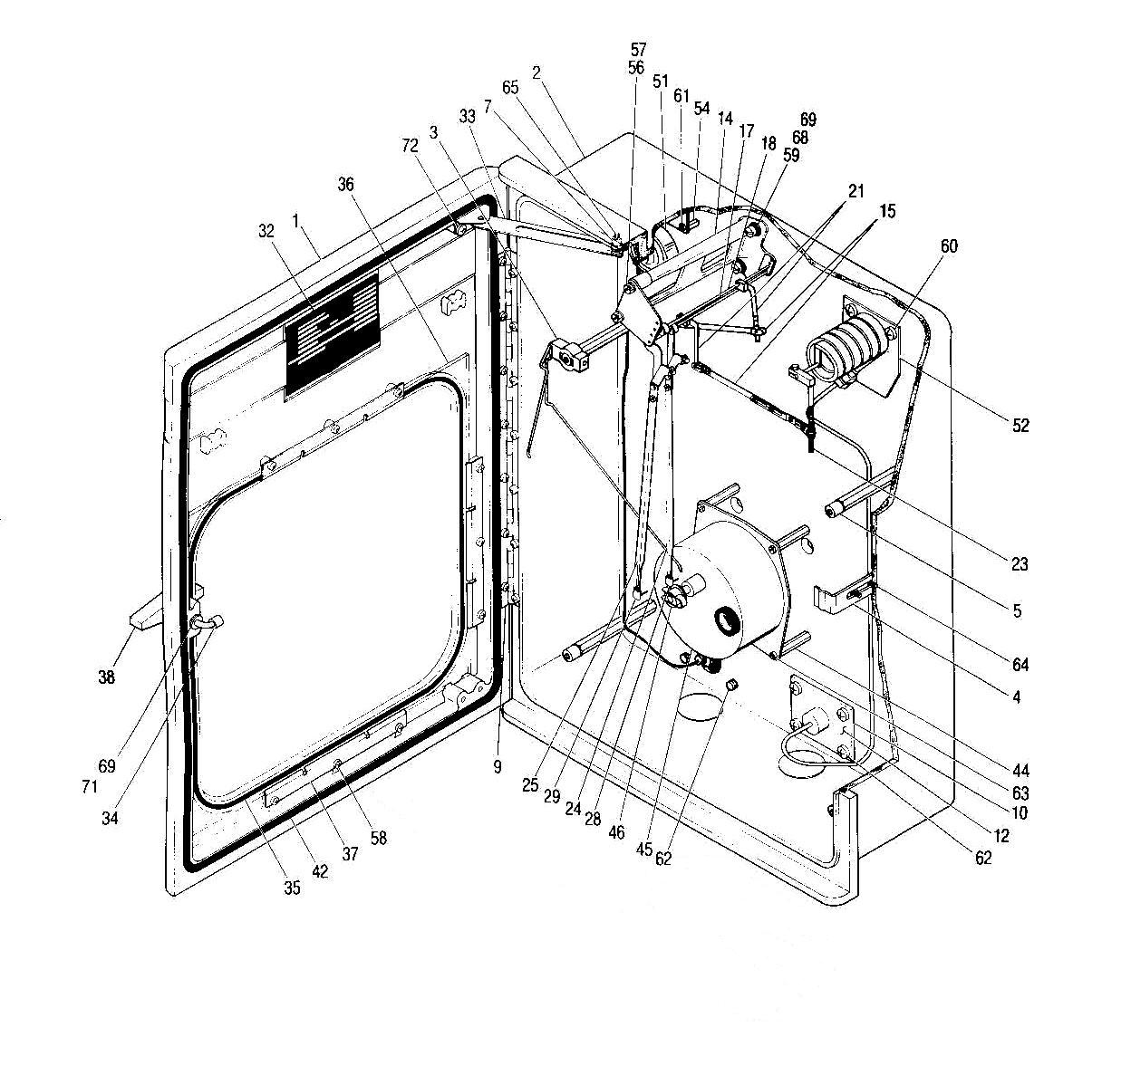
Pressure and Temperature Recorder
O.G.M.E. Recorder Parts List

ITEM# | DESCRIPTION
1 | Recorder door
2 | Recorder case
3 | Pen lifter
4 | Door latch
5 | Chart plate riser
6 | Not shown
7 | Door stop bushing
8 | Not shown
9 | Door hinge
10 | Static pressure connection gasket
11 | Not shown
12 | Static pressure connection
13 | Not shown
14 | Pen mount assembly
15 | Link assembly
16 | Not shown
17 | #1 Pen shaft
18 | #2 Pen shaft
19 | Not shown
20 | Not shown
21 | 45° and 90° driven arm
22 | Not shown
23 | Static drive arm
24 | Pen arm
25 | Pen arm
26 | Not shown
27 | Not shown
28 | #1 Disposable blue pen
29 | #2 Disposable red pen
30 | Not shown
31 | Not shown
32 | Data tag
33 | Door stop assembly
34 | Door latch assembly
35 | Door glass gasket
36 | Door glass
37 | Door glass clip
38 | Door handle
39 | Not shown
40 | Not shown
41 | Not shown
42 | Door gasket
43 | Not shown
44 | Chart drive riser
45 | Chart drive
46 | G190 Chart hub
47 | Not shown
48 | Not shown
49 | Not shown
50 | Not shown
51 | Temperature element
52 | Pressure element
53 | Not shown
54 | Temperature element risers
55 | Not shown
56 | Pen mount top plate screw
57 | Pen mount top plate washer
58 | Door glass clip screw
59 | Pen mount assembly mounting screw
60 | Panhead screw 10-32 x 5/16 SS
61 | Panhead screw 10-32 x 5/16 SS
62 | Panhead screw 10-32 x 5/16 SS
63 | Panhead screw 6-40 x ¼ SS
64 | Panhead screw 10-32 x 5/16 SS
65 | Panhead screw 10-32 x ¾ SS
66 | Not shown
67 | Not shown
68 | Pen mount assembly mounting washer
69 | Pen mount assembly mounting lock washer
70 | Not shown
71 | Door latch assembly washer
72 | Panhead screw 10-32 x 5/16 SS
73 | Not shown
74 | Not shown
75 | Not shown
76 | Not shown
77 | Not shown

Recorder Dimensions



